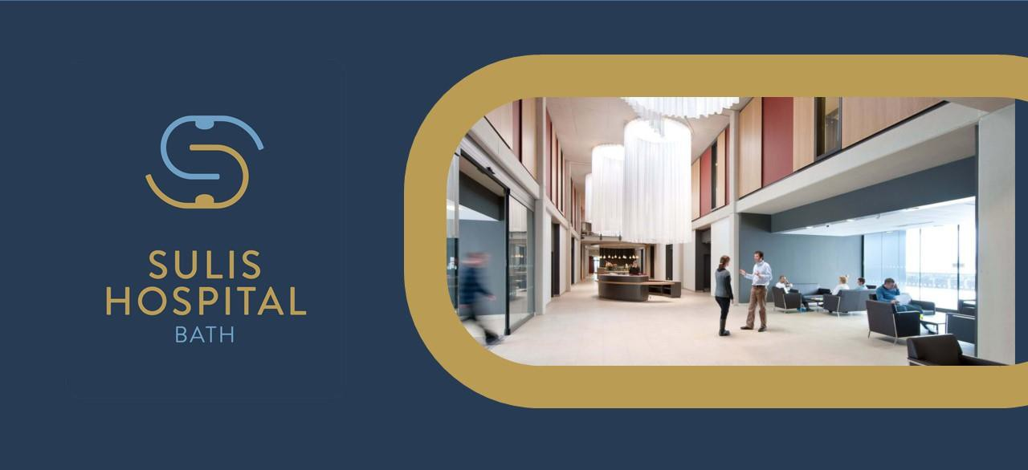

Job description

Job title | Service Operational Manager (Elective Care)
Grade | Grade G / Grade H
Reporting to | Head of Commercial Operations
Line Management | None
Location | Sulis Hospital Bath
Role Summary | We are seeking a full-time Service Operational Manager for Sulis Hospital Bath’s Elective Surgical pathways.  The post holder will be responsible for the effective operational delivery of NHS and private elective surgical performance. Supporting pathways and maximizing utilisation to increase patient throughput.  The post holder will work in partnership with the Clinical Leads, External Stakeholders, Sulis and Elective Recovery System Lead and will report to the Head of Commercial Operations ensuring operational issues are addressed in a timely fashion and ensure that Sulis Hospital Bath collectively achieves the challenging access, financial and clinical governance standards.  The postholder will bring together key pathways within the SOC programme and across Sulis Hospital; leading and monitoring delivery and supporting new initiatives to become established.  The post holder will have a good understanding of the emerging Department of Health and NHSE strategic direction and ensure that the teams are ready to respond to this challenging and changing agenda.  The postholder will take lead responsibility for ensuring the Sulis Hospital Bath elective surgical benchmarks positively compared to budgeted targets and quality performance. They will continue to develop a culture of continuous improvement within the programme.
Main Duties and Responsibilities | ELECTIVE PATHWAY MANAGEMENT  - Provide guidance to Admin Manager and team as well as clinical administration teams on patient pathways, support and carry out necessary actions to move patients forward and have a plan per patient.  - Lead elective care training for Sulis using in-depth examples in Compucare, other clinical systems, and elective care portals.  - Support the Admin Lead to manage the overall PTLs and liaise with the staff within services so all are aware on who is looking at certain weeks wait to gain movements per patients, to prevent staff duplicating work within the services.  - Attending tracking meetings when required to give support to the Admin Lead and clinical Leads where necessary.  - Create and manage SOP’s / Crib sheets for elective care including admissions add and remove from waiting list, updating patient level details, creating referrals)  - Prepare weekly reports for performance meetings, 38-week month end breaches, 52 weeks month end breaches, 52 weeks on the day breaches/  - Attend Sulis Hospital wide weekly huddle meetings and advising, guiding teams and Unit Leads of next steps required for patients within their PTL’s.  Performance Management  - Responsible for overall safe and smooth delivery of identified services as set out in the hospital’s business plan and service frameworks.  - Responsible for delivering admitted and performance targets and metrics, including outcome objectives and service line reporting.  - Interpret data available within the service to report, monitor and track performance and to satisfy reporting requirements within the designated areas of responsibility.  - Work in partnership with the Business Intelligence Team to provide specialty specific reports which feedback performance to the Head of Commercial Operations and other senior staff.  - Monitor levels of admitted activity against expectations and highlight any adverse variance to the Head of Commercial Operations and Operational Teams.  - Ensure that public and patient user views are taken into account in the planning and monitoring of services.  SERVICE IMPROVMENT  - With the unit leads supports the development of efficient, effective, and high-quality patient focused services that is responsive to changing patterns of healthcare in conjunction with relevant stakeholders.  - Identify opportunities and develop plans for service redesign, utilising service improvement techniques in line with the Sulis’ corporate strategy.  - Inform the development and implementation of annual business plans, which support the overall strategy of Sulis Hospital.  - Undertake performance reviews of the service, forecasting trends and developments that affect service delivery and provide information as requested.  - Participate in negotiations of service level agreements as required.  - To analyse and respond to ad-hoc situations in a timely, but objective manner when unplanned changes in supply/demand.  - Ensure implementation of clinical governance, complaints, and risk management process for the service in monitoring of compliance with clinical governance standards, other Hospital-wide policies and processes and best practice requirements.  - Assess and analyse complex data gathered from various sources, together with own audits as and when required, in order to identify patterns and trends to enable effective and informed decision making and long-term planning of services.  - In conjunction with the Head of Commercial Operations and Unit Leads support the delivery of the strategy as well as addressing recruitment, retention, induction, support and development of all staff within the service, in collaboration with relevant stakeholders in line with the business plan.  - Responsible for ensuring that all staff managed by the post holder have job appropriate and mandatory training and personal development plans.  - Ensure staff compliance with appropriate Sulis Hospital and HR policies and procedures.  - Line manage, coach, motivate and develop team morale through effective personal leadership.  - Manage reporting on budget positions across the service to support the Delivery

 | - All other duties as required in line with the grading of this role.
Safeguarding children and vulnerable adults | All employees and volunteers working within Sulis Hospital have a responsibility for safeguarding and promoting the welfare of children and vulnerable adults. Initial and refresher training is available to enable you to understand and carry out your duties in relation to safeguarding.
Health and Safety | - To take reasonable care to prevent injury to themselves or others who may be affected by their acts or omissions.  - To co-operate fully in discharging the Sulis Hospital policies and procedures with regard to health and safety matters.  - To immediately report to their manager any shortcomings in health and safety procedures and practice.  - To report any accidents or dangerous incidents to their line manager and safety representative as early as possible.  - To use protective clothing and equipment where provided.

Compliance Responsibilities and Confidentiality | Sulis Hospital provides NHS care under Standard Acute contract and is currently registered and monitored by CCG through their contracts. Its activity is regulated and monitored by the Care Quality Commission; consequently the post holder is expected to work in compliance with the Health and Social Care Act 2012 (Regulated Activities), the Care Quality Commission (Registration) Regulations 2014 and other relevant and subsequent legislation.
 | The post holder must maintain confidentiality of information about staff, patients and Sulis Hospital business activities and are expected to respect the requirements under the Data Protection Act 1998 and Access to Health Records Act (1990) and any new appropriate legislation that affects safe patient care within their sphere of working.
 | Comply with Sulis Hospital’s Information Security Management Policies, a copy of which is available online in Insight, to ensure that information systems such as the internet, intranet access, e-mail, desktop systems, and mobiles are used in a professional manner for business purposes only. Information held on such systems must be treated as confidential, especially where that information relates to patients.
 | The post holder will comply with all Infection Prevention and Control policies and take the appropriate action fitting their role to actively prevent or reduce the incidence of healthcare associated infections.
 | Staff have a responsibility to reduce and recycle waste and save energy and water.
 | Undertake initial and refresher mandatory training to ensure compliance at all times
This job description is not an exhaustive list of duties but is intended to give a general indication of the current range of work undertaken and will vary in detail in the light of changing demands and priorities within Sulis Hospital.

Person specification

Person specification | Essential | Desirable
1. Physical  requirements | - Occupational Health clearance for the role specified.
2. Education and qualifications | - Educated to degree level in relevant subject or equivalent level of experience of working at a similar level in project management/ support.  - Significant experience in supporting clinical systems  - GCSEs or equivalent in English and Maths. | - Experience with CDC programme and/or equivalent projects.
3. Previous  experience relevant to the post | - Experienced in working in a similar position and in project support/ management.  - Experience in communicating with individuals external to the business.  - Experience of facilitation, presentation and of delivering end-user training. | - Experience in the private hospital sector.  - Experience of working with senior managers and leaders.
4. Skills, knowledge and abilities | - Ability to pull together comprehensive draft reports  - Excellent IT and Excel skills.  - Strong attention to detail.  - Ability to work to tight deadlines and multiple priorities.  - An ability to communicate effectively with people at all

 | - Ability to work independently and with minimum supervision.
5. Aptitude and personal characteristics e.g. aptitude for figures, special demands of the post | - Comfortable and experienced with working with different stakeholders.  - Ability to problem solve and look for ways to improve processes.  - Possess initiative and self- motivated.  - A positive attitude and forward thinking.  - Highly adaptable and ability to problem-solve.

I confirm that I have read all the information detailed in this Job Description / Person Specification and understand what is expected of me:

Signed

Postholder ………………………………………………………….
Date …………………………………

Signed

Manager ………………………………………………………………
Date ………………………………..

